Guided Capstone Project Report

The purpose of Big Mountain ski resort project is to build a pricing model for the ski resort ticket in its market segment. It also reviews what changes could be made to maximize the resort return, capitalize on existing resort’s facilities. It also provides recommendations for the resort’s new investment strategy (future facilities) based on the importance of some facilities compare to others and produce a guidance for Big Mountain's pricing in the future.

We built our data model based on the data from 330 ski resorts across the United State.

Our model suggest that the Big Mountain Resort price should be $95.87, the actual price is $81.00. Even with the expected mean absolute error of $10.39, this suggests there is room for an increase.

It seems that our resort seems to be charging that much less that what's predicted suggests our resort might be undercharging.

We checked where Big Mountain sits overall amongst all resorts for price and for just other resorts in Montana.

The Big Mountain ticket price is in middle range comparing with other resorts in US but it is one of the most expensive resorts in the state of Montana

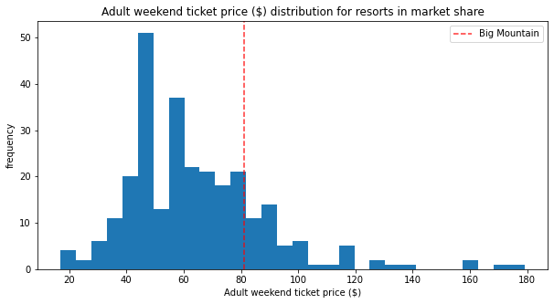

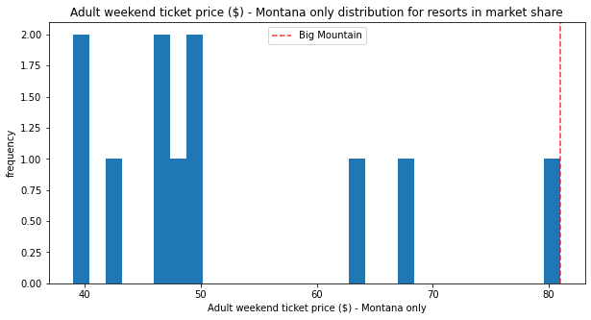

Our model also suggested that the ticket price should depends on the resort’s facilities. We found out that the following features are the features customers are willing to pay extra

* vertical_drop,
* Snow Making_ac,
* total_chairs,
* fastQuads,
* Runs,
* LongestRun_mi,
* trams
* SkiableTerrain_ac

The results show that Big Mountain resort is already in high up league tables for all features among the other resorts.

We had been reviewing the potential scenarios for either cutting costs or increasing revenue (from the ticket price)

The business has shortlisted some options that we reviewed:

1. Permanently closing down up to 10 of the least used runs.

*Big Mountain resort has 105 runs. Our model showed that closing one run will make no difference on price and revenue. Closing 2 and 3 reduces support for ticket price and so revenue. If Big Mountain closes down 3 runs, it seems they may as well close down 4 or 5 as there's no further loss in ticket price. Increasing the closures down to 6 or more leads to a large drop.*

1. Increase the vertical drop by adding a run to a point 150 feet lower down but requiring the installation of an additional chair lift to bring skiers back up, without additional snow making coverage

*Increasing the vertical drop by 150 feet, and installing an additional chair lift. This scenario increases support for ticket price by $1.99. Over the season, this could be expected to amount to $3474638*

1. Same as number 2, but adding 2 acres of snow making cover

*Such a small increase in the snow making area makes no difference.*

1. Increase the longest run by 0.2 mile to boast 3.5 miles length, requiring an additional snow making coverage of 4 acres

*No* *difference whatsoever. Although the longest run feature was used in the linear model, the random forest model (the one we chose because of its better performance) only has longest run way down in the feature importance list.*

Although, the Big Mountain resort seems a very well equipped and very well priced among other resorts in US. Our model suggests a higher price based on the other states data but Big Mountain is already on the top price range within the state I wouldn't recommend to increase the current price without additional research. The price strategy could depend on how popular is the resort (is it fully booked the whole season?). Also, some additional information about proximity to a big city/airport/airlines’ hubs (flight ticket prices) and etc. comparing to other popular resorts destinations could be helpful.

I would recommend to consider reducing the operating cost or consider to create a ticket packages make the cheaper prices for customers staying a week or more and higher prices for the short-term customers instead of current fix price per day.